**ASSIGNMENT 2**

Task 1:

Structure:

-Struct: is a collection of properties that are all related to the same object. A set of qualities relating to a person, such as name, age, and gender. In my program, struct declare name, ID, math grade, science grade, chemistry grade and GPA.

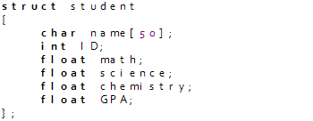

-Do…while loop: is a while loop version. It checks its condition at the bottom of the loop. It helps my program to make sure there are no negative numbers when inputting.

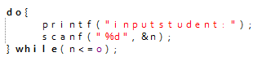

-For loop: is a repetition control structure that allows you to design a loop that be executed a certain number of times.

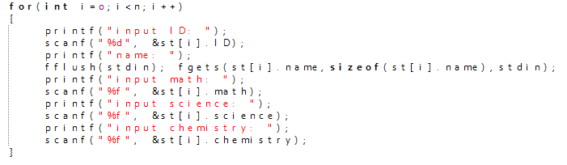

-Switch…case: it lets you to choose one of several code blocks to run. In other words, it replaces many if…else statements.

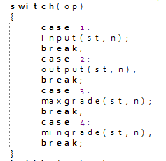

Functions:

-stdio.h: contains input and output functions.



-string.h: handle character arrays.



-main(): has the effect of beginning the program.

-void(): is commonly used in functions, which specify the type of the function’s arguments and the type of the return value.

Data types:

-char: stores a single character and requires a single byte of memory in almost all compilers.



-int: is used to store an integer.



-float: is used to store decimal numbers with single precision.



Beginning program

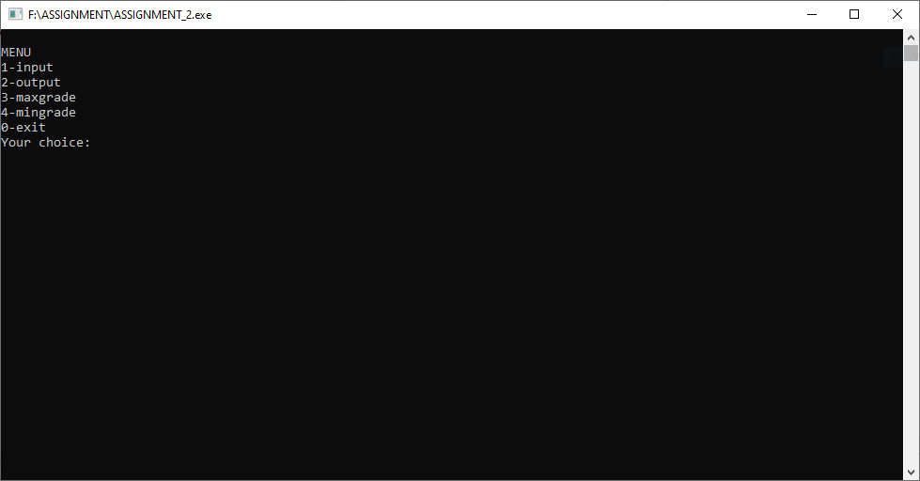

Option 1: input

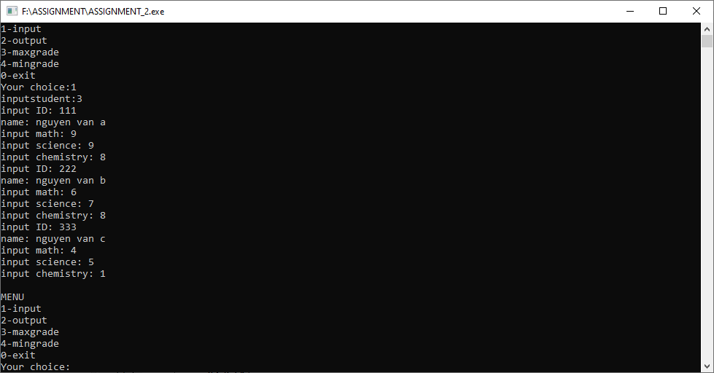

Option 2: output

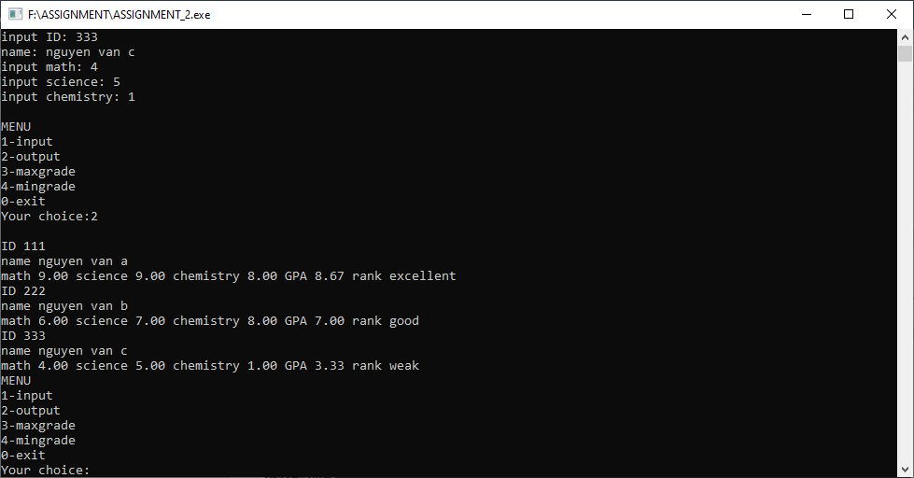

Option 3: GPA maximum output

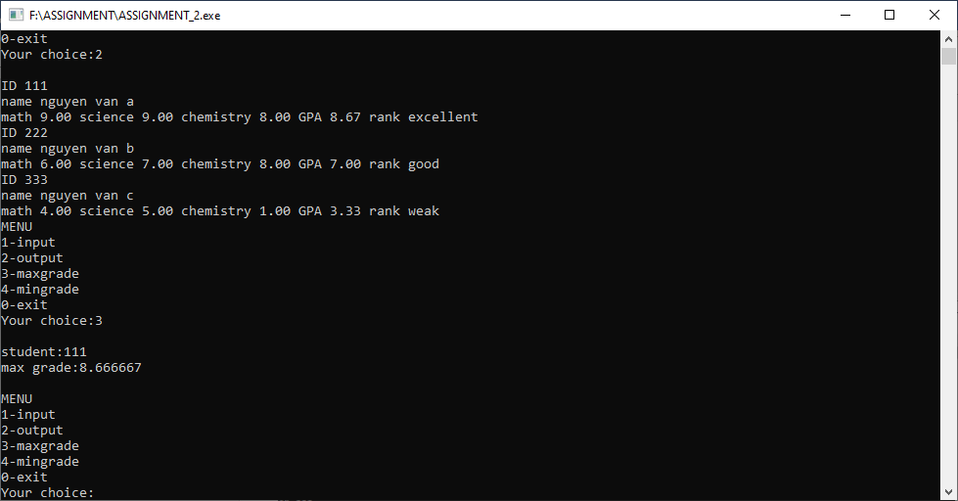

Option 4: GPA minimum output

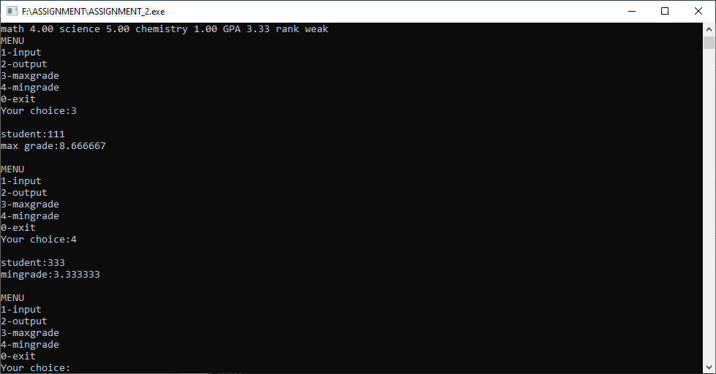

Option 5: exit

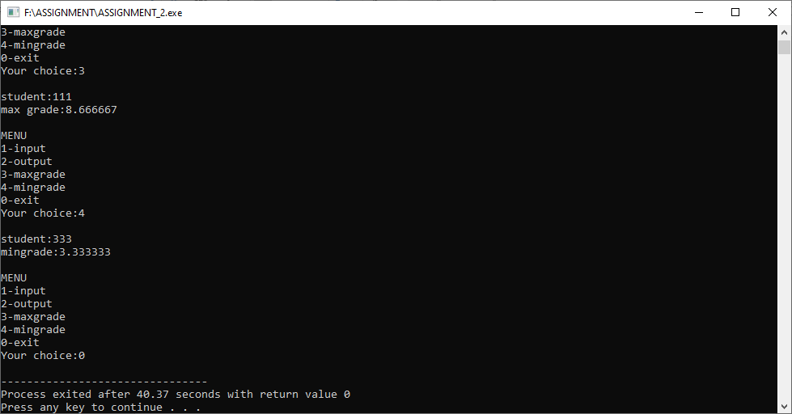

Task 2:

|  |  |  |  |  |
| --- | --- | --- | --- | --- |
| Test | What is being tested | How | Test data used | Expected Results |
| 1 | Examine the MENU option | Enter data other than the menu | 5 | The menu repeats continuously until the correct data is entered in the menu |
| 2 | Validation of input | Enter data student is a negative number | -1 | Invalid data and re-entry required |
| 3 | Accurate calculations | Enter data for math, science, and chemistry | math:5  science:7  chemistry:9 | GPA=7 is correct |

Task 3:

Evaluation and conclusion:

My program solved the problem in this scenario. But if adding another feature to the program, it will probably take a long time to determine. I should guarantee that it will not interfere with what is running properly in the program in the future. That is the lesson I learned after finishing the program.

Advantages of procedural programming:

-Procedural programming is so simpler, so newcomers can learn easily as their first programming language.

-The C programming language offers a large function library that is appropriate for many applications.

-The overall development cost and time are significantly reduced by using standard library functions.

Disadvantages of procedural programming:

-Large and complicated software projects shouldn’t use procedural programming.

-The upkeep of the software is not too simple.